

Faculty of Engineering

Shoubra-Benha University

Name:-**ياسمين عبدالحميد علي عبدالحميد**

B.N:- **1034**

Date:- **22/5/2020**

# Topic:- Computer Architecture

Application Brief:-

Computer architecture is a specification describing how hardware and software technologies interact to create a computer platform or system. When we think of the word architecture, we think of building a house or a building. Keeping that same principle in mind, computer architecture involves building a computer and all that goes into a computer system. Computer architecture consists of three main categories.

System design – This includes all the hardware parts, such as CPU, data processors, multiprocessors, memory controllers and direct memory access. This part is the actual computer system.

Instruction set architecture – The includes the CPU’s functions and capabilities, the CPU’s programming language, data formats, processor register types and instructions used by computer programmers. This part is the software that makes it run, such as Windows or Photoshop or similar programs.

Microarchitecture – This defines the data processing and storage element or data paths and how they should be implemented into the instruction set architecture. These might include DVD storage devices or similar devices.

All these parts go together in a certain order and must be developed in a pattern so they will function correctly.

**Screenshots:-**

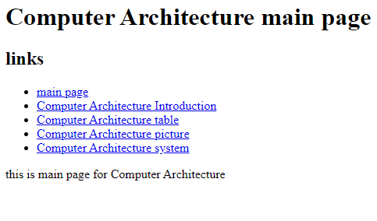

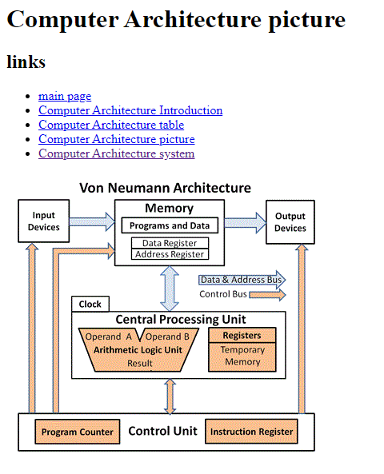

**Source Code:-**

